PAC-Poly-Hi-Hi-Annaeho’omalu-Ki’i-Vesicular Lava-500 CE

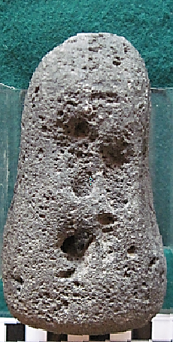 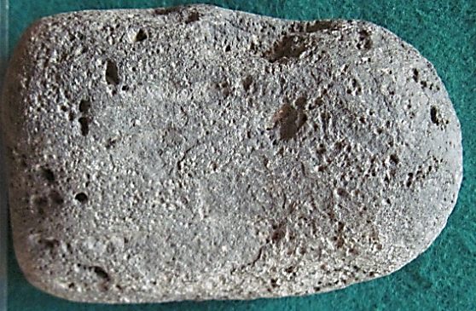 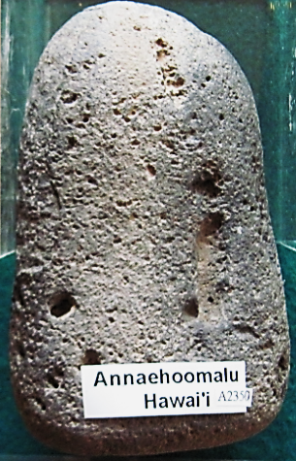

**Case no.: 20**

**Accession Number:**

**Formal Label: Hawai‘i,** Annaeho’omalu-Ki’i-Vesicular Lava-500 CE

**Display Description:**

**This ki’i of vesicular lava is from Annaeho’omalu on the Island of Hawai‘i. It probably dates to the earliest settlement of the west shore of the island of Hawai‘i c 1200 CE as it is of a very primitive shape in the vague anthropomorphic form of the sea god Kanaloa abraded naturally by the Pacific Ocean’s action on cobbles.**

**LC Classification:**

**Date or Time Horizon:**

**Geographical Area:**

**Map:**

**GPS coordinates:**

**Cultural Affiliation:**

**Media:**

**Dimensions:**

**Weight:**

**Condition:**

**Provenance:**

**Discussion:**

**References:**

bannister